CSP 1.1.8 - Turtles in Traffic

Kyle Huang - CSP Period 5

[Link to Google Doc (If reading from PDF)](https://docs.google.com/document/d/1Vtxme5iK5PFIKycTv10-S7ltZx3qaV_FrVK1hv9QJn8/edit?usp=sharing)

17. (17 on PLTW, but not on canvas assignment)

| # a118_grades.py  my_courses = ["English", "Math", "CS"]  for course in my_courses:  redo = "y"  while (redo == "y"):  print() # blank line  print("Enter your points for " + course)  points = int(input("Points -> "))    if (points >= 90):  print("A")  elif (points >= 80):  print("B")  elif (points >= 70):  print("C")  elif (points >= 60):  print("D")  else:  print("F")    redo = input("Do you need to re-do these grades? (y/n)") |
| --- |

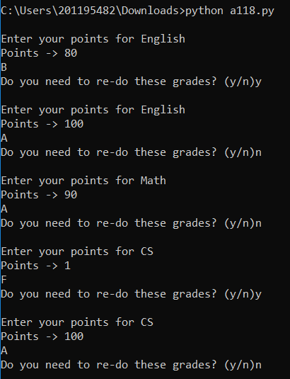

20. (17 on canvas, but 20 on PLTW)

| # a118_turtles_in_traffic.py  # Move turtles horizontally and vertically across screen.  # Stopping turtles when they collide.  import turtle as trtl  # create two empty lists of turtles, adding to them later  horiz_turtles = []  vert_turtles = []  # use interesting shapes and colors  turtle_shapes = ["arrow", "turtle", "circle", "square", "triangle", "classic"]  horiz_colors = ["red", "blue", "green", "orange", "purple", "gold"]  vert_colors = ["darkred", "darkblue", "lime", "salmon", "indigo", "brown"]  tloc = 50  for s in turtle_shapes:  ht = trtl.Turtle(shape=s)  horiz_turtles.append(ht)  ht.penup()  new_color = horiz_colors.pop()  ht.fillcolor(new_color)  ht.goto(-350, tloc)  ht.setheading(0)  vt = trtl.Turtle(shape=s)  vert_turtles.append(vt)  vt.penup()  new_color = vert_colors.pop()  vt.fillcolor(new_color)  vt.goto( -tloc, 350)  vt.setheading(270)  tloc += 50  # TODO: move turtles across and down screen, stopping for collisions  steps = 0  while steps < 50:  for ht in horiz_turtles:  collision = False  for vt in vert_turtles:  ht.forward(3)  vt.forward(3)  if (abs(ht.xcor()-vt.xcor()) <= 20 and abs(ht.ycor()-vt.ycor()) <= 20):  if (not collision):  horiz_turtles.remove(ht)  ht.fillcolor("gray")  vert_turtles.remove(vt)  vt.fillcolor("gray")  collision = True  steps = steps + 1  wn = trtl.Screen()  wn.mainloop() |
| --- |

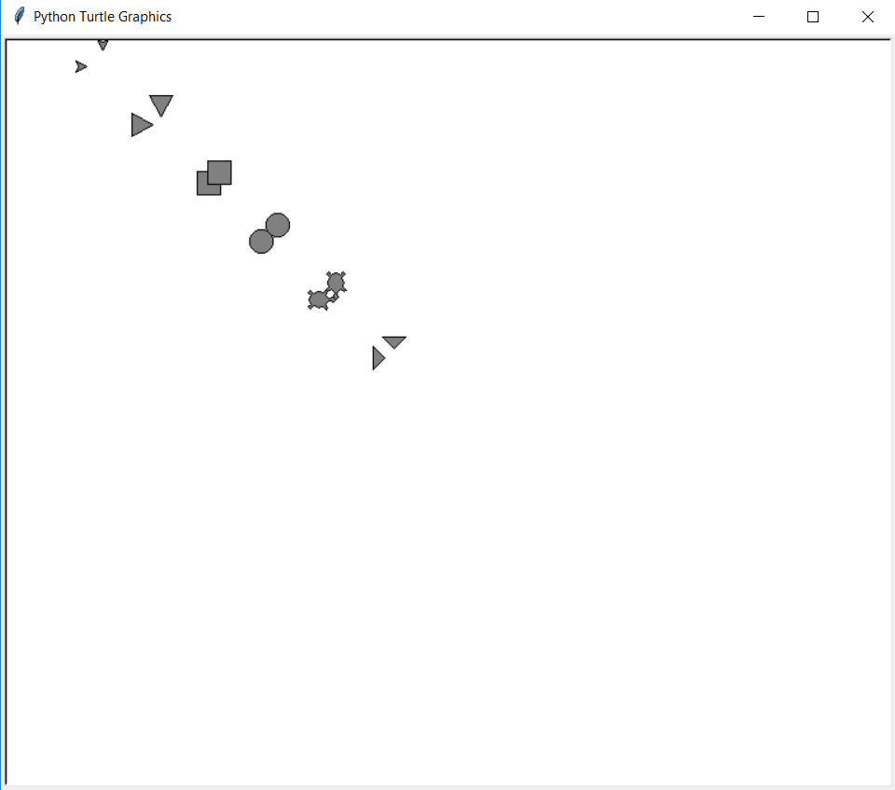

21. (18 on canvas, but 21 on PLTW)

| # a118_turtles_in_traffic.py  # Move turtles horizontally and vertically across screen.  # Stopping turtles when they collide.  import turtle as trtl  # create two empty lists of turtles, adding to them later  horiz_turtles = []  vert_turtles = []  # use interesting shapes and colors  turtle_shapes = ["arrow", "turtle", "circle", "square", "triangle", "classic"]  horiz_colors = ["red", "blue", "green", "orange", "purple", "gold"]  vert_colors = ["darkred", "darkblue", "lime", "salmon", "indigo", "brown"]  tloc = 50  for s in turtle_shapes:  ht = trtl.Turtle(shape=s)  horiz_turtles.append(ht)  ht.penup()  new_color = horiz_colors.pop()  ht.fillcolor(new_color)  ht.goto(-350, tloc)  ht.setheading(0)  vt = trtl.Turtle(shape=s)  vert_turtles.append(vt)  vt.penup()  new_color = vert_colors.pop()  vt.fillcolor(new_color)  vt.goto( -tloc, 350)  vt.setheading(270)  tloc += 50  # TODO: move turtles across and down screen, stopping for collisions  steps = 0  while steps < 50:  for ht in horiz_turtles:  collision = False  for vt in vert_turtles:  ht.forward(steps%12)  vt.forward(steps%12)  if (abs(ht.xcor()-vt.xcor()) <= 20 and abs(ht.ycor()-vt.ycor()) <= 20):  if (not collision):  horiz_turtles.remove(ht)  ht.fillcolor("gray")  vert_turtles.remove(vt)  vt.fillcolor("gray")  collision = True  steps = steps + 1  wn = trtl.Screen()  wn.mainloop() |
| --- |

Note: the turtles still crash at the same spots, but get there faster.

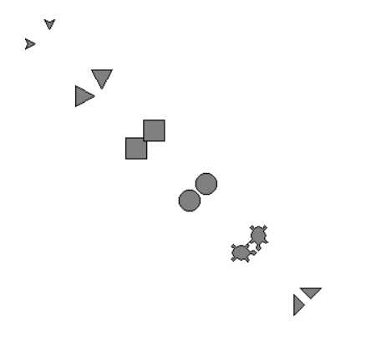

22. (19 on canvas, but 22 on PLTW)

[python file](https://drive.google.com/file/d/12twBogmOzZ1YkAxs4GUX8QPqXo-gJglu/view?usp=sharing)

| # a118_turtles_in_traffic.py  # Move turtles horizontally and vertically across screen.  # Stopping turtles when they collide.  import turtle as trtl  # create two empty lists of turtles, adding to them later  horiz_turtles = []  vert_turtles = []  # use interesting shapes and colors  turtle_shapes = ["arrow", "turtle", "square", "triangle", "classic"]  horiz_colors = ["blue", "green", "orange", "purple", "gold"]  vert_colors = ["darkred", "darkblue", "lime", "salmon", "indigo"]  crashed_turtles = []  tloc = 50  for i in range(len(turtle_shapes)):  s = turtle_shapes[i]  ht = trtl.Turtle(shape=s)  horiz_turtles.append(ht)  ht.penup()  new_color = horiz_colors[i]  ht.fillcolor(new_color)  ht.goto(-350, tloc)  ht.setheading(0)  vt = trtl.Turtle(shape=s)  vert_turtles.append(vt)  vt.penup()  new_color = vert_colors[i]  vt.fillcolor(new_color)  vt.goto( -tloc, 350)  vt.setheading(270)  tloc += 50  # TODO: move turtles across and down screen, stopping for collisions  steps = 5  while steps < 55:  for ht in horiz_turtles:  for vt in vert_turtles:  speed = ((steps%10)-5)*((steps%10)-5)/3  if (crashed_turtles.__contains__(ht)):  ht.forward(max(-speed*4,-30))  ht.shape(turtle_shapes[horiz_turtles.index(ht)])  ht.fillcolor(horiz_colors[horiz_turtles.index(ht)])  crashed_turtles.remove(ht)  if (crashed_turtles.__contains__(vt)):  vt.forward(max(-speed*6,-45))  vt.shape(turtle_shapes[vert_turtles.index(vt)])  vt.fillcolor(vert_colors[vert_turtles.index(vt)])  crashed_turtles.remove(vt)  if (ht.xcor() <= 200):  ht.forward(speed)  if (vt.ycor() >= -200):  vt.forward(speed)  if (abs(ht.xcor()-vt.xcor()) <= 20 and abs(ht.ycor()-vt.ycor()) <= 20):  ht.shape("circle")  ht.fillcolor("red")  vt.shape("circle")  vt.fillcolor("red")  crashed_turtles.append(ht)  crashed_turtles.append(vt)  steps = steps + 1  # End of program notifier  for i in range(len(horiz_turtles)):  horiz_turtles[i].color("gray")  vert_turtles[i].color("gray")  wn = trtl.Screen()  wn.mainloop() |
| --- |

During a collision:

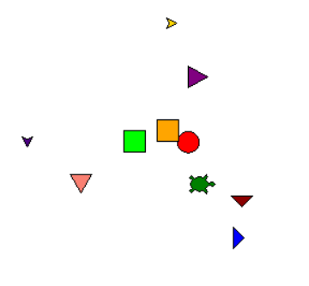

End of Program:

